**Ticketing**

Smart Card is your key to Kolkata Metro and has been designed to make your travel easier. It is a durable, reusable smartcard with an embedded computer chip which automatically calculates and deducts the correct fare for your journey. Your smartcard is easy to use; you simply touch it on the AFC&PC gate as you pass through the ticket gates and again when you leave the system at the end of your journey with the correct fare being deducted from your card. Remember to touch on at the beginning and touch off at the end of every journey. Smart Cards are available at all Metro stations. In addition to above Smart Tokens are also available for journey.

* **SMART TOKEN**
  + Token is meant for single journey. There is no provision for return journey

token.

* Token is captured at the exit gate on completion of journey.
* Token is valid for the day of purchase for a particular zone of travel depending on origin and destination. Once purchased across a booking counter, passenger must enter the paid area within 45 minutes from the time of purchase. Token becomes invalid if the passenger does not enter within 45 minutes.
* A token holder is allowed to detrain short of his booked zone of travel without any penalty. He is also permitted a proper exit at the destination station without having entry punched on the token. Lost token is not replaced under any circumstances.
* **SMART CARD**
* Smart Cards are sold at all Kolkata Metro stations.
* The first-time user will have to purchase the smart card by paying Rs.150/200/300/500 & 1000 (inclusive of Security Deposit of Rs. 80/-) and later on get the pass value recharged for any amount of Rs.100/200/300/500 & 1000, up to maximum card balance of Rs.5000/-. A 10% bonus on flat rate is given on issuing new smart card (minus SD) and further on recharging of smart card.
* Validity of such card is one year from the date of purchase or date of “add value”. In case the smart card is topped up within validity period, the balance amount remaining on the card is carried forward. In case the validity of card has expired at the time of “topping up”, recharging can be done on the smart card; however, the previous balance is not carried forward but forfeited.
* A passenger is allowed to enter through the entry gate only with a minimum balance of Rs.25/-(the maximum chargeable fare).
* In case a patron does not flash his smart card at the exit and makes an improper exit, the card is locked. The booking counter deducts the maximum chargeable fare Rs.25/- from the smart card when the same is presented in the next visit and the card is unlocked.
* When a passenger tries to exit with a card without proper recorded entry in it, the passenger is deemed to be travelling without ticket. Such a mismatch is penalized by deducting Rs.25/- from the smart card.
* Lost card is not replaced under any circumstances
* **STUDENT SMART CARD**
* Student smart card is sold only at the booking counters of selected stations of Kolkata Metro. This card is issued in favour of 2 fixed stations.
* On student smart card, there is a ride restriction wherein a student can avail two rides per day on a student smart card.
* Concession of 60% of the chargeable fare is granted to students attending School / Madrasas / Vocational Institutions up to classes academically equivalent to Class – XII. Any other discount on the basis of add value is not applicable.
* The first time user is to pay one time security deposit of Rs.80/- for purchasing the student smart card and get the pass value loaded for 40 or 80 Rides.
* Validity of student smart card is 30 days and 90 days according to value loaded for 40 rides and 80 rides respectively. When this card is recharged before the validity period the balance rides, if any, are carried forwarded. After the validity is over, the same card again can be recharged as per requirement but balance rides, if any, are not carried forward.
* The rule of replacement of the student smart card is same as general Smart Card.
* When a student makes an improper exit without flashing his card on the gate, the card gets locked. One ride is deducted when the card is presented to the booking counter in the next visit and simultaneously the card gets unlocked.
* When a student tries to exit with a card without proper entry recorded in it, the student is deemed to be travelling without ticket. He is liable to pay penalty of Rs.250/- in addition to maximum fare in cash chargeable at that exit point.
* **TOURIST SMART CARD**

Type of tourist smart cards and details thereof are as under:

|  |  |  |  |
| --- | --- | --- | --- |
| Types of Tourist Smart Card | Cost of Smart Card (Rs.) | Security Deposit (refundable) (Rs.) | No. of rides permitted |
| Tourist Smart Card-I | 250.00 | 80.00 | Unlimited rides for three days |
| Tourist Smart Card-II | 550.00 | 80.00 | Unlimited rides for five days |

* After the validity of the tourist card is over, the same can be recharged as per the convenience of the tourist.

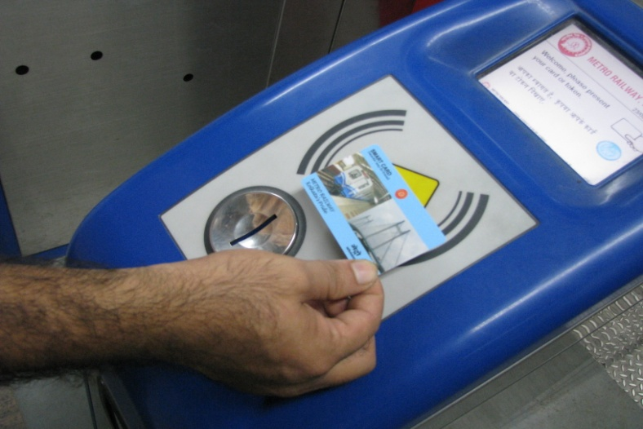

**Smart Card for MLAs against Rail Travel Coupons (RTC)**

* Rail Travel Coupons (RTC) is a numbered booklet containing coupons of various denominations in serial order issued to the MLAs / Ex. MLAs of West Bengal Government. Such booklets are to be used only by MLAs / Ex. MLAs whose name is specified on the coupon booklet. The booklet is valid for a period of 3 years from the date of its issue. These coupons are not transferable. If the concerned MLA does not undertake the journey himself / herself against the coupons issued to him / her, the CSC(Contactless Smart Card) / CST(Contactless Smart Token) for companion is not issued against coupons. Coupons are presented for the face value of the CSC / CST at the booking counter for purchase. If the coupons available in the booklet are not sufficient for journey, MLA / Ex.MLA is required to pay the balance amount in cash at full tariff rate. However, if coupons from two different booklets are presented in favour of the same MLA / Ex.MLA for issue of ticket, the same is accepted. If members are found travelling with coupons, and not valid tickets, they are considered travelling without ticket and the penalty is imposed as per rule. There is no refund on unused coupons. Any refund on token/card purchase through Rail Travel Coupons (RTC) is done as per the rules applicable for other similar tickets but the refund is made only to the State Government and not to the individual members.

|  |  |  |  |  |
| --- | --- | --- | --- | --- |
| Persons authorized to use RTC | Single journey CST | CSC | Recharge of CSC | Special Conditions |
| MLAs of West Bengal Assembly | Permitted maximum two.  (MLA+ One Companion) | Permitted | Permitted | Refund allowed . |
| Ex-MLAs of West Bengal Assembly | Permitted, maximum two.  (Ex.MLA+ One Companion) | Not permitted | Not permitted | No refund allowed. |

* Break Journey
* No break journey is allowed in Metro Railway, Kolkata.
* Children below the age of 5 years are allowed free travel in Metro services.